

W5 - PRACTICE
JSX - Dynamic Data - Components
 At the end of this practice, you should be able to…
- Create a new component from HTML
- Translate HTML to JSX
- Understand the basic of nested components
- Draw a diagram component from some given code
- Understand how to display data dynamically using curly braces {xx} in JSX
 How to work?
- Download the start code from the Google classroom ✔ For each exercise you can either:
  - Run npm install
  - Or move an existing node_modules to the exercise folder (fastest option!)
How to submit?
- Create a repository on GitHub with the name of this practice:
Ex: C2-S1-PRACTICE
- Push your final code on this GitHub repository (if you are lost, follow this tutorial)
- Finally, submit on Google classroom your GitHub repository URL
Ex: https://github.com/thebest/ C2-S1-PRACTICE.git

 Are you lost?
You can read the following documentation to be ready for this practice:
https://www.w3schools.com/react/react_jsx.asp https://www.w3schools.com/react/react_props.asp https://www.gatsbyjs.com/docs/how-to/images-and-media/importing-assets-into-files/



EXERCISE 1
Your task is to create your first React component!

You have an App component, containing the header and the body.
- Create a component Header containing the header of the file.
- Change the code in the App component to use this new component

Notes:
● You can create the component directly in the App file.

The finished app could look like this:
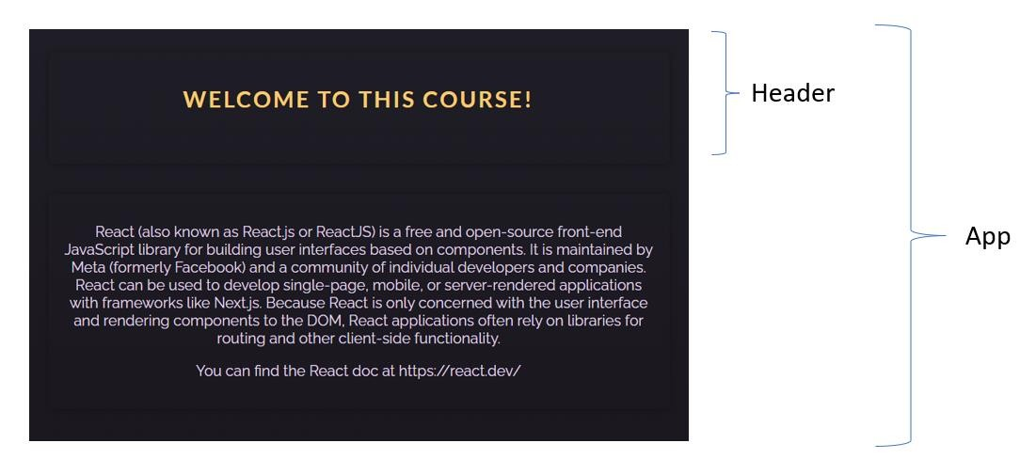
The finished app diagram component:

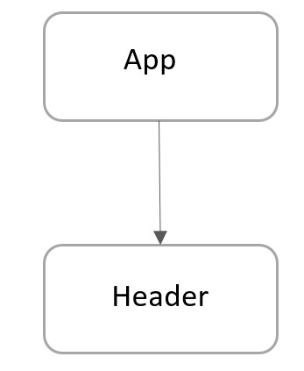

EXERCISE 2
Well done!
Now your challenge is to convert some vanilla HTML into some React JS code!

Q1 – Research on internet and list down the main differences between HTML and JSX syntax
- HTML is static, JSX is dynamic
- HTML use class, JSX use className
- HTML the self closing tag is opt for most element while JSX is a must
html:
<h1>Hello</h1>
<p>World</p>
jsx:
return (
<>
<h1>Hello</h1>
<p>World</p>
</>
)

Q2 – The first part is to create an empty React project which display Hello

- Create a new React project using the following command:
npm create vite exercise2 -- --template react

- On the root folder, remove the following useless file:
.eslintrc.cjs
README.md
.gitignore

- On /src folder remove, remove the following useless file:
/assets
App.css

- Edit the index.css and remove all styles
- Edit the App.jsx and just write a simple code:
function App() { return (
<>
<p>Hello</p>
</>
); } export default App;

- From the root folder, launch npm install and npm run dev
- You have now a very simple ReactJS code that displays Hello:


Q3 – On this second part you need to adapt the original HTML code to your new created project:

Your code should be composed of 4 components, as bellow:
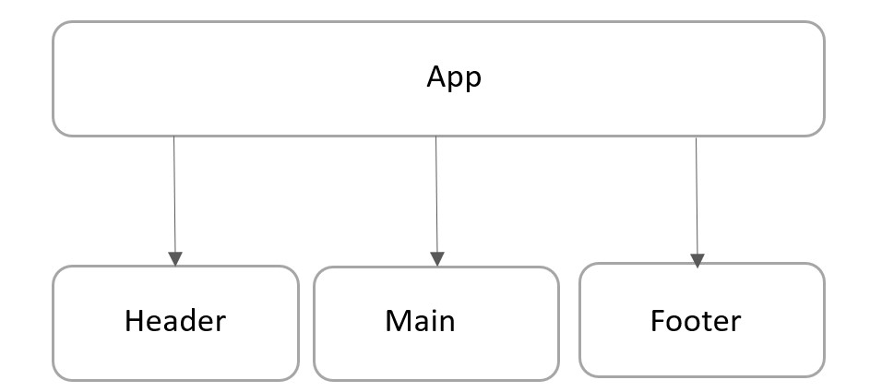

- Create a folder /components
- In this folder create 3 additional JSX files:
o Header.jsx o Main.jsx o Footer.jsx
- Adapt the code from the original HTML code to those 4 compomers (App, header, Body and
Footer) o Do not forget to export your components to use them outside!

- Finally, you can copy the original CSS code to your new project

The finished app could look like this:
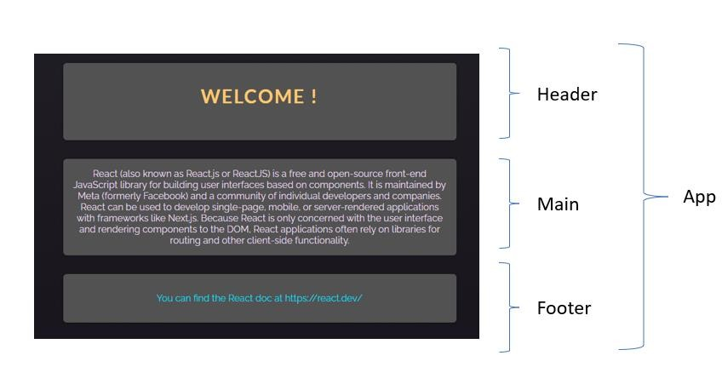

EXERCISE 3
Amazing!

Q1 - Now your challenge is to draw a diagram component from some existing React JS code.
- Read the code
- Identify components
- Draw the diagram component (using power point or another tool)

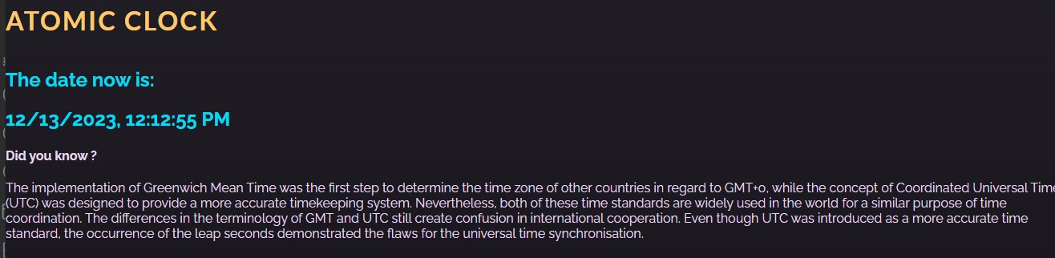

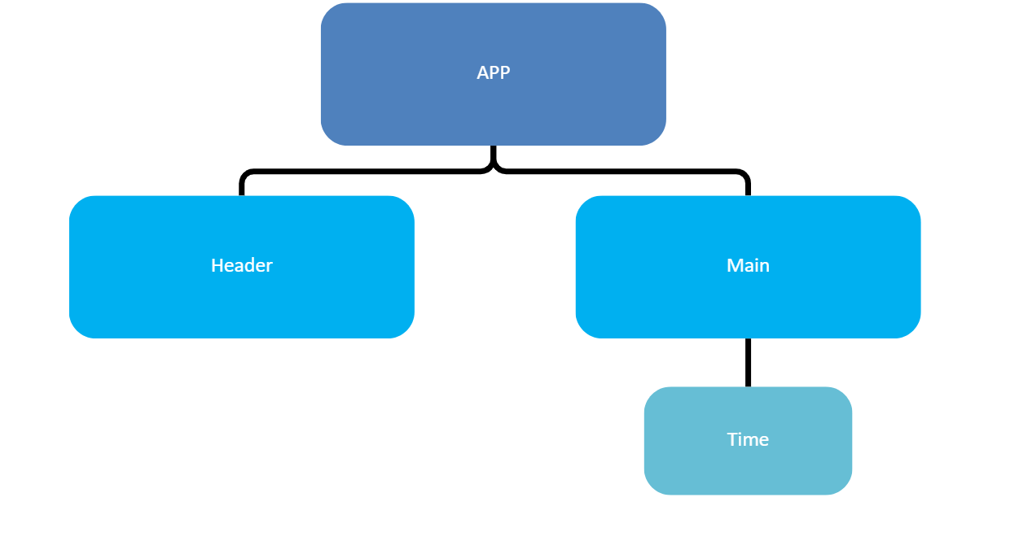

Q2 – Let’s play with dynamic data:

- In Header, change the title to: “The amazing atomic clock”

- In Time component, change the code to display only the time only (not date + time)



EXERCISE 4
Amazoooome!
For this last exercise, your challenge is to provide the dynamic data for the 2 following fields:
- The value (15 dollars) converted in Dong
- The value (15 dollars) converted in Euro

Important
- You need to implement and call the functions already provided for you to convert dollar to other devices
- All inputs are disabled: we use them for display only, not to enter any value…

